Project 2A

Team members: Enmao Diao, Haoli Du

**Explain the diffusion-based model**

Originally, we have model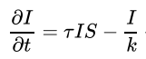. The new term 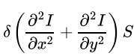 represents diffusion term that allows infected individuals to affect susceptible individuals that are close to them in space. This term is added to I(t,x,y) and subtracted from S(t,x,y). This means that once adding this term, neighbors which are closer to the infected cells at a given time t have a higher probability to be infected. Because only the susceptible ones are infected, we multiply the diffusion term 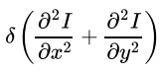 with S. This term introduces the **Fick's second law** to predict how diffusion causes the concentration to change with time. In 1-D diffusion we only have diffusion on one dimension; since we are simulating over 2-D space we compute the diffusion terms along both x and y axis.

C:\Users\Administrator\AppData\Roaming\Tencent\Users\344748443\QQ\WinTemp\RichOle\YH$`M8N5%6}}OCTLWF~K%~1.png is the diffusion coefficient which has units of squared length over time. This constant is reasonable; we can see that from the units. I(t,x,y) represents the concentration of infected people in cell (x,y) at time t. It has the unit (#of infected people)/unit area. Then has unit (#of infected people)/(unit area*unit time). On the RHS, the term has unit (#of infected people)/(unit area^3) since we do partial differentiation twice on I(t,x,y). Obviously, we need a constant which has unit (unit area^2)/(unit*time) to balance two sides Depending on how we want to bias the diffusion direction we can set different value for the diffusion coefficient.

**Implement Model 4**

Model 4

We implement the model 4 following the instruction of diffusion and infection model. We first set up a matrix of (M+2)x(N+2) cells for a given M and N. This means we added a boundary for the grid to detect diffusion out of the system since the values of the surrounding cells will be non zero if that happens. Each cell represents a distinct location for which the diffusion occurs. Next we setup the equations for I, S and R for calculating changes in each individual cell. We then run odeint over the entire domain with the given timesteps. Finally, we plot the initial and final state of I, S and R. We set two cells in the graph to have the initial infected population as 1. You can clearly see that from the Initial Infected and Initial S plot. One thing worths mentioning is that in the Final Infected plot, the cells may appear to be completely blue; in fact those cells have very small S value. The color bar is kept consistent for all 3 graphs of a given timestep to show the difference between the 3 population.

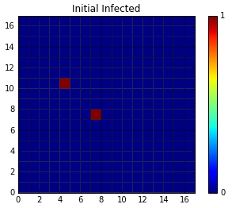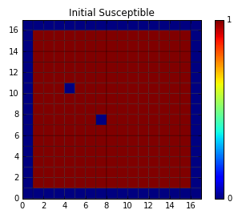

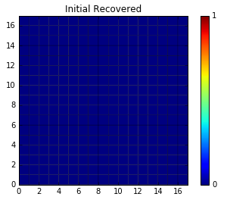

**Figure 1(a)(b)(c). Initial state of the Infected, Susceptible and Recovered.**

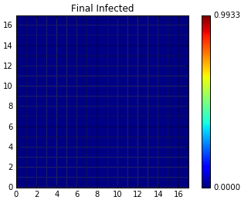

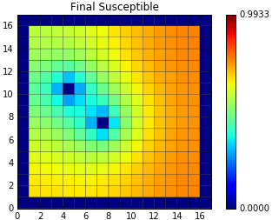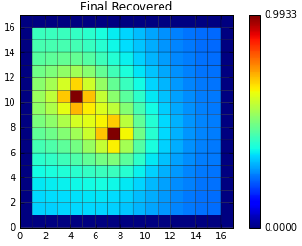

Figure 2(a)(b)(c). Final state of the Infected, Susceptible and Recovered.

Challenge A

In this challenge, we set the initial state as the problem described and we plot of average I, S, R changing over time. We stop computation once the I or S value reach below 1e-5. In order to calculate the average, we sum up I, S and R values from each cell and divided by M*N, in this case 11*11. We avoid using numpy.mean because this function takes the boundary cells into account and results in incorrect calculations. One thing that bothered us for a long time was that we did not specify the correct boundary conditions for diffusion. This somehow results in rapid recover. When we fix this bug, everything works perfectly. Compared with other models without spatial variation, Model 4 has higher infection rate because each cell is also influenced by its neighbor cells. More susceptible people tend to be infected. Compared with the delay Model 3, however, it has smaller infection rate. This is simply because the delay model actually slows down the recover rate which is the dominant reason of decreasing infection rate.

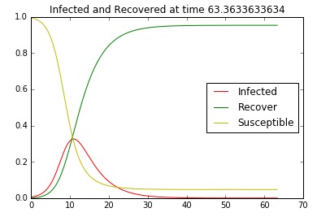

Figure 3. The average value of I, S and R vs time.

Challenge B

In this Challenge, we add another term “Vaccinated” to our computation. In other words, susceptible population will have a chance not being infected. As you can see from by comparing Figure 3 and 4, with Vaccination, the simulation shows that it actually has a smaller peak infection rate and it also reaches 1e-5 threshold sooner.

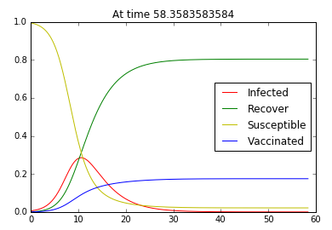

Figure 4. The average value of I, S and R vs time with vaccination.